Solent University

# INTRODUCTION TO DATABASES

# FINAL ASSESSMENT

Author and student number: Natalia Bochnia, 10181827

Unit title: Introduction to Databases

Date: 23.05.2022

Table of Contents

INTRODUCTION TO DATABASES 1

FINAL ASSESSMENT 1

PART 1 - Retrieving Data using SQL 2

QUESTION A: 2

QUESTION B: 4

QUESTION C: 7

QUESTION D: 9

PART 2 – Database Design, Implementation and Integrity 11

QUESTION A: 11

QUESTION B: 12

QUESTION C: 12

QUESTION D: 14

# **PART 1 - Retrieving Data using SQL**

## **QUESTION A:**



**SQL CODE:**

SELECT shopper_first_name AS FirstName,shopper_surname AS Surname,shopper_email_address AS EmailAddress,IFNULL(gender,'Not Known') as Gender,strftime('%d/%m/%Y',date_joined) as Date_joined, strftime('%Y','now')- strftime('%Y',date_of_birth) AS current_age

FROM "shoppers"

WHERE date_joined >= "01-01-2020" AND gender = "F"

ORDER BY `current_age` DESC;

**EXPLANATION:**

In above query, I fetched a data from shoppers table using WHERE and ORDER BY conditions based on the asked question. I changed the formate of date using strftime() date format function. For checking null values if exits use IFNULL function and replace the null values with not known. Althought it is not showing when only Female gender is selected, but when we do not select the gender it is working as it should (Screenshot in testing section).

**SCREENSHOT:**

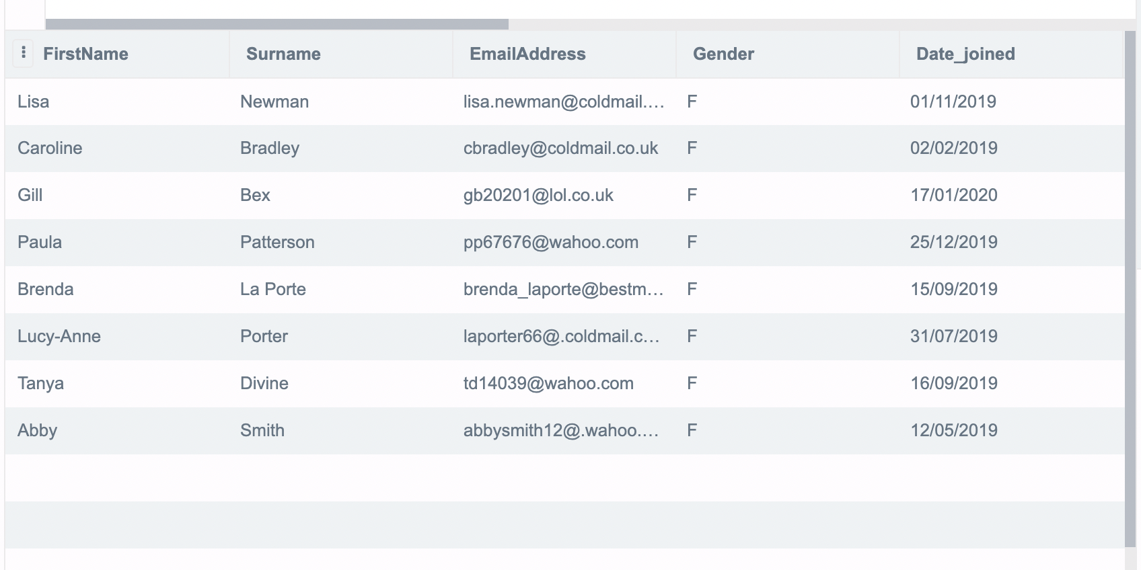

**TESTING:**

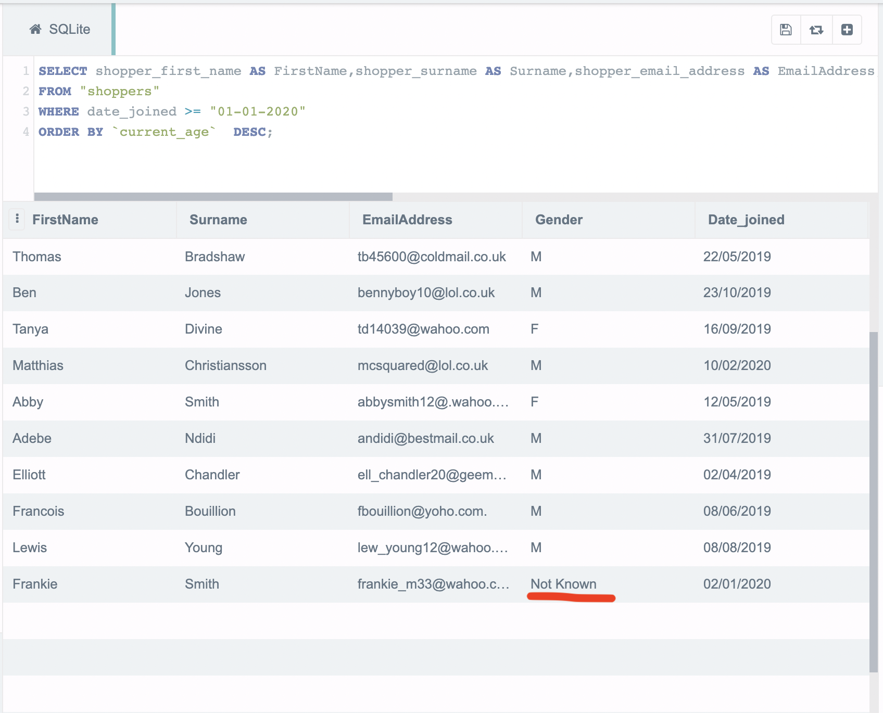

## **QUESTION B:**

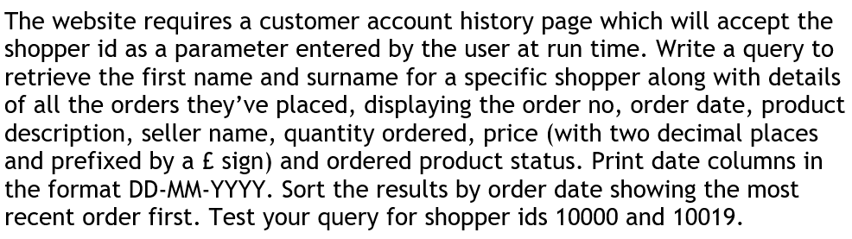

**SQL CODE:**

* **ID=10000**

SELECT s.shopper_first_name,s.shopper_surname, so.order_id,strftime('%d-%m-%Y',so.order_date) as "Date", p.product_description, se.seller_name, op.quantity, ('£ '||printf("%.2f", op.quantity *op.price )) as `Price`, op.ordered_product_status

FROM shoppers s, shopper_orders so, products p, ordered_products op, sellers se

WHERE s.shopper_id = so.shopper_id and so.order_id = op.order_id and op.product_id = p.product_id and op.seller_id = se.seller_id and s.shopper_id=10000

ORDER BY "Date" DESC;

* **ID = 10019**

SELECT s.shopper_first_name,s.shopper_surname, so.order_id,strftime('%d-%m-%Y',so.order_date) as "Date", p.product_description, se.seller_name, op.quantity, ('£ '||printf("%.2f", op.quantity *op.price )) as `Price`, op.ordered_product_status

FROM shoppers s, shopper_orders so, products p, ordered_products op, sellers se

WHERE s.shopper_id = so.shopper_id and so.order_id = op.order_id and op.product_id = p.product_id and op.seller_id = se.seller_id and s.shopper_id=10019

ORDER BY "Date" DESC;

**EXPLANATION:**

In the above example I am using concatenate operator (||) to join two strings into one. I also used printf(“%.2f”) function to format a number to two decimal places.

**SCREENSHOT:**

ID = 10000

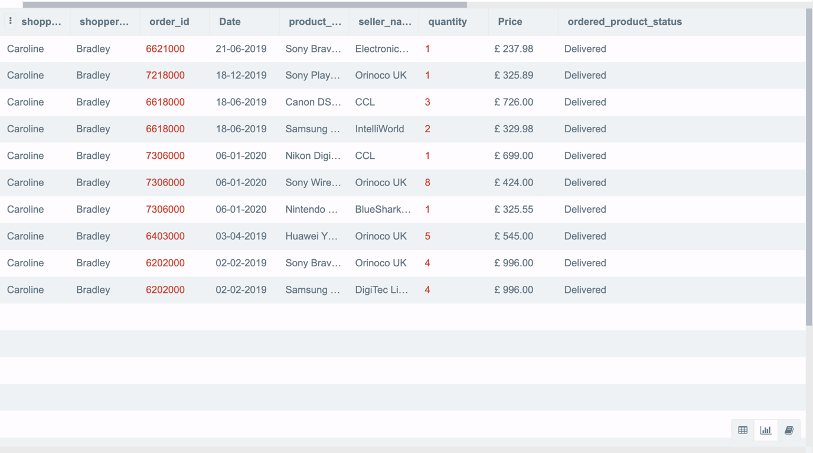

ID = 10019

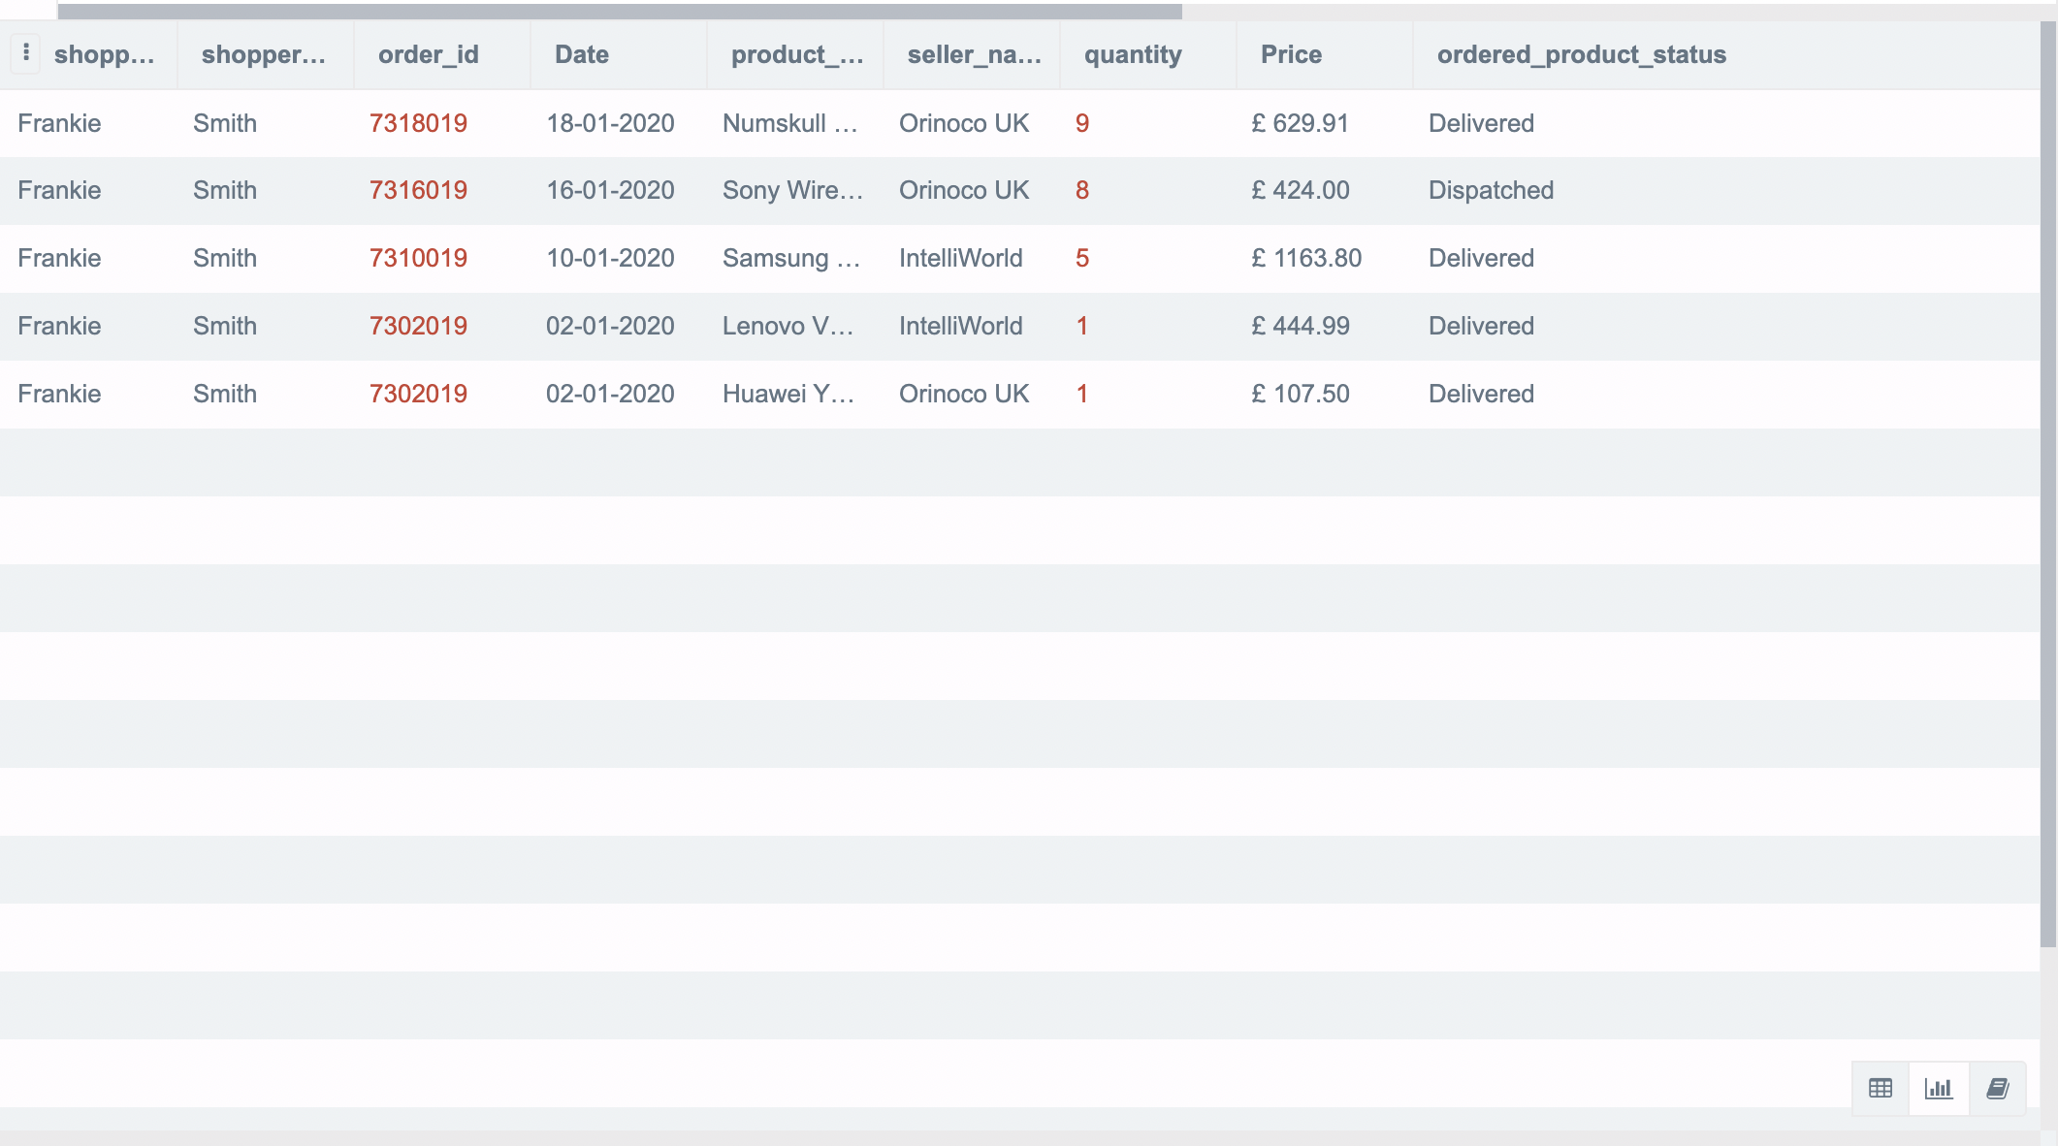

**TESTING:**

I tested it with a different shopper id and it was working as well.

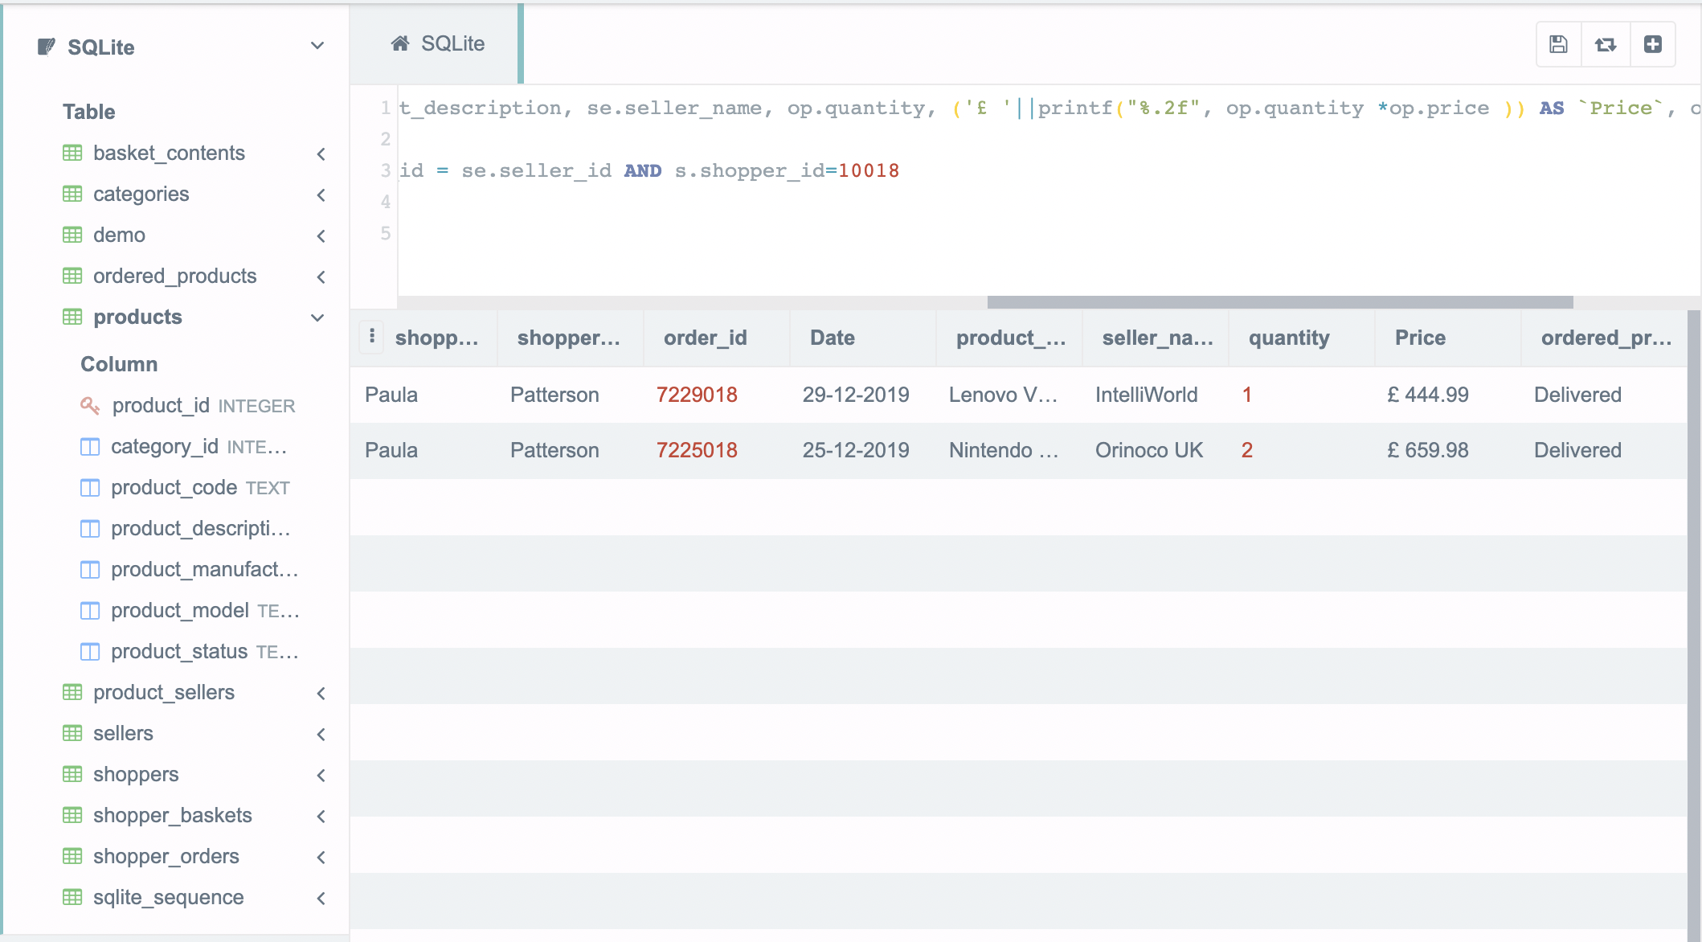

## **QUESTION C:**

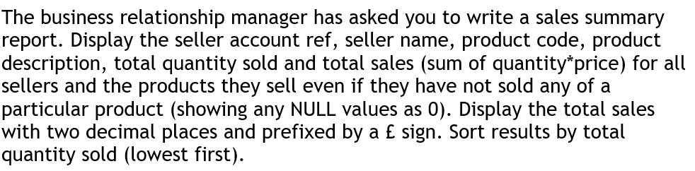

**SQL CODE:**

SELECT seller_account_ref, seller_name, product_code, product_description, IFNULL(COUNT(op.order_id),0) AS No_of_orders, IFNULL(SUM(op.quantity),0) AS total_quantity_sold, ('£ '||printf("%.2f", op.quantity *op.price )) as total_sales

FROM sellers se, products p, ordered_products op

WHERE op.seller_id=se.seller_id AND op.product_id=p.product_id

GROUP BY se.seller_name

ORDER BY SUM(op.quantity) ASC

**EXPLANATION:**

**SCREENSHOT:**

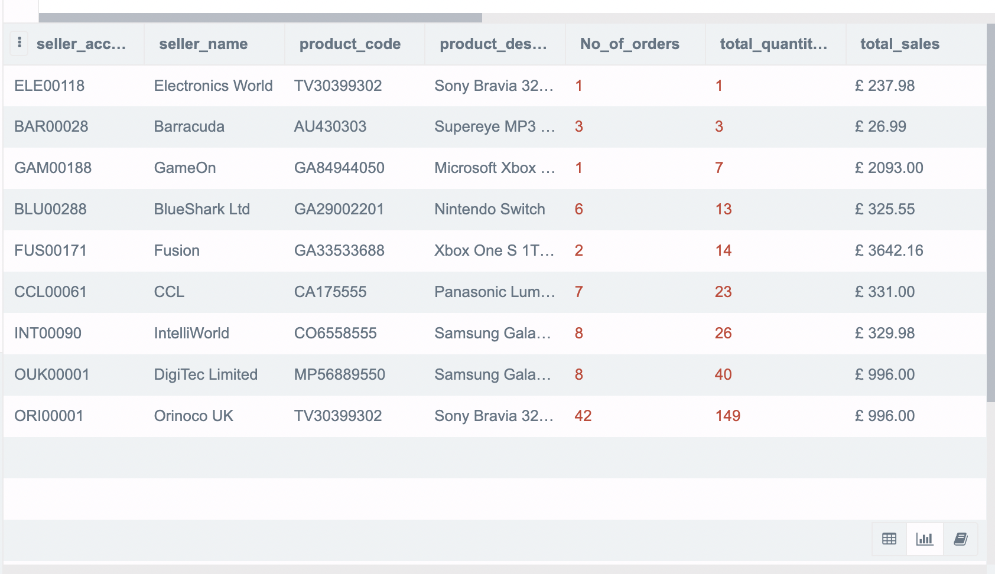

**TESTING:**

I removed “AND op.product_id=p.product_id” and as we might excpect the output is completely different.

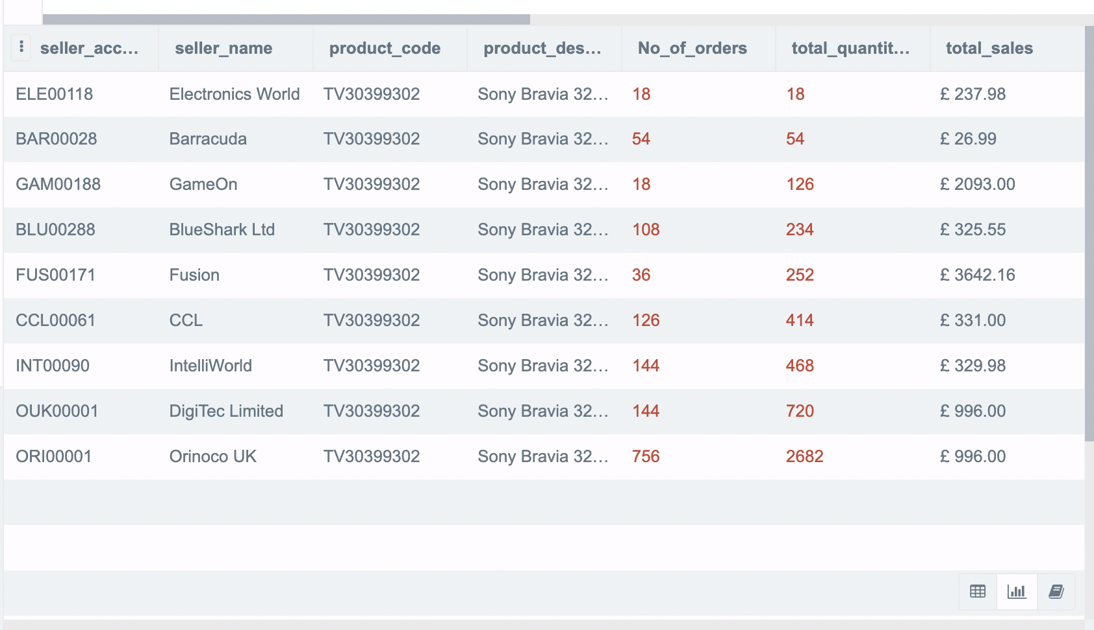

## **QUESTION D:**

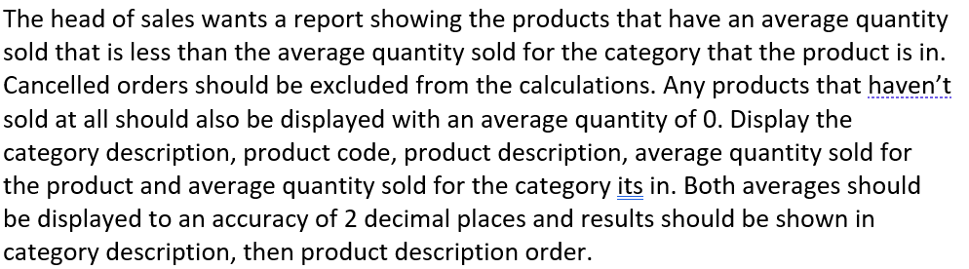

**SQL CODE:**

**By category description:**

SELECT c.category_description , p.product_code, p.product_description, ROUND(IFNULL(AVG(op.quantity),0),2) AS AVG_QTY_Sold,

ROUND(IFNULL(AVG(op.quantity)*COUNT(p.category_id),0),2) AS AVG_QTY_Sold_For_Category

FROM categories c,products p,ordered_products op

WHERE op.ordered_product_status NOT LIKE "cancelled" AND op.product_id=p.product_id and c.category_id=p.category_id

GROUP BY c.category_description

ORDER BY c.category_description, p.product_description

**By product description:**

SELECT c.category_description , p.product_code, p.product_description, ROUND(IFNULL(AVG(op.quantity),0),2) AS AVG_QTY_Sold,

ROUND(IFNULL(AVG(op.quantity)*COUNT(p.category_id),0),2) AS AVG_QTY_Sold_For_Category

FROM categories c,products p,ordered_products op

WHERE op.ordered_product_status NOT LIKE "cancelled" AND op.product_id=p.product_id and c.category_id=p.category_id

GROUP BY p.product_description

ORDER BY c.category_description, p.product_description

**EXPLANATION:**

I calculated average quantity by using ROUND and COUNT functions by multiplying quantity with the price with points of 0 and 2. I fetched data based on product description first then category description, to do this I used GROUP BY statement.

**SCREENSHOT:**

**By category description:**

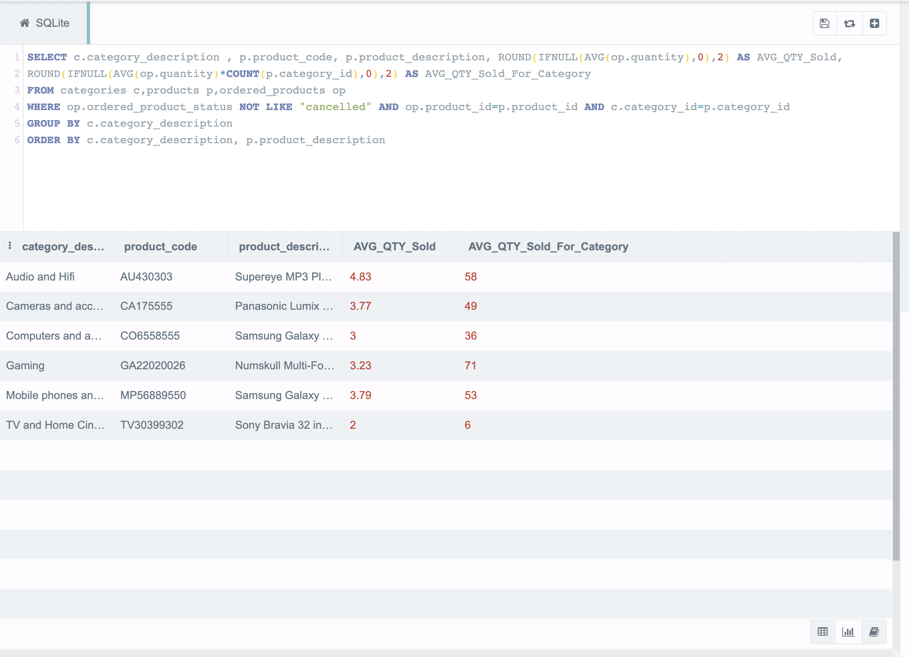

**By product description:**

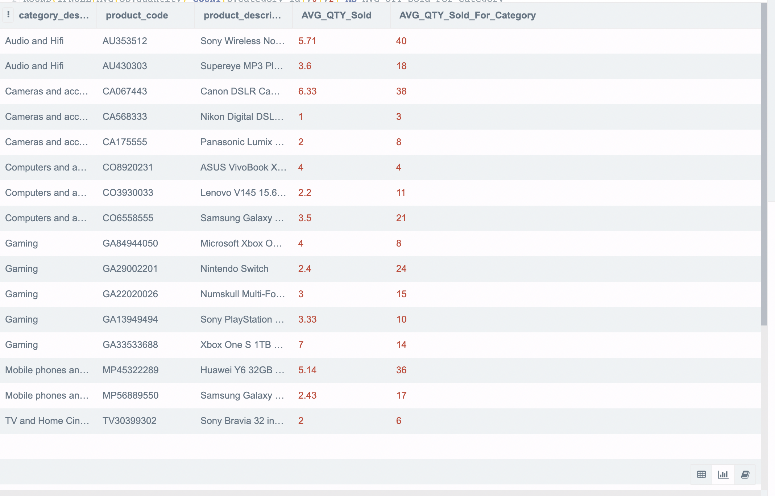

# **PART 2 – Database Design, Implementation and Integrity**

## **QUESTION A:**



I have tried to create a tables of seller review with a customer comment and number of stars that was given as well as seller_review_id which was my primary key in that case.

I created a similar table but with the product review and a comment as well as star review and id. As I thought this were missing tables in this data set.

Then I populated my tables with some information such as comments, id numbers, and star rating.

I also tested this code and checked if was correct.

## **QUESTION B:**



## **QUESTION C:**



CREATE TABLE IF NOT EXISTS "Seller_Reviews" (

"seller_review_id" INTEGER,

"seller_comment" text NOT NULL,

"seller_star_reviews" text NOT NULL,

PRIMARY KEY("seller_review_id" AUTOINCREMENT)

);

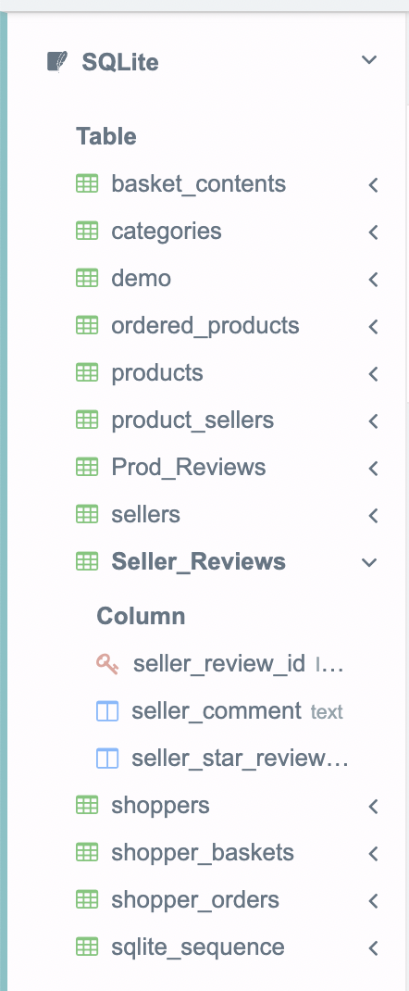

CREATE TABLE IF NOT EXISTS "Prod_Reviews" (

"Prod_review_id" INTEGER,

"prod_comment" text NOT NULL,

"star_reviews" text NOT NULL,

PRIMARY KEY("Prod_review_id" AUTOINCREMENT)

);



In Product review table:

INSERT INTO "prod_reviews" ("Prod_review_id", "prod_comment", `star_reviews`) VALUES (NULL, 'nice product with good service', '4 stars');

INSERT INTO `prod_reviews` (`Prod_review_id`, `prod_comment`, `star_reviews`) VALUES (NULL, 'great product', '5 stars');

INSERT INTO `prod_reviews` (`Prod_review_id`, `prod_comment`, `star_reviews`) VALUES (NULL, 'very poor product', '2 stars');

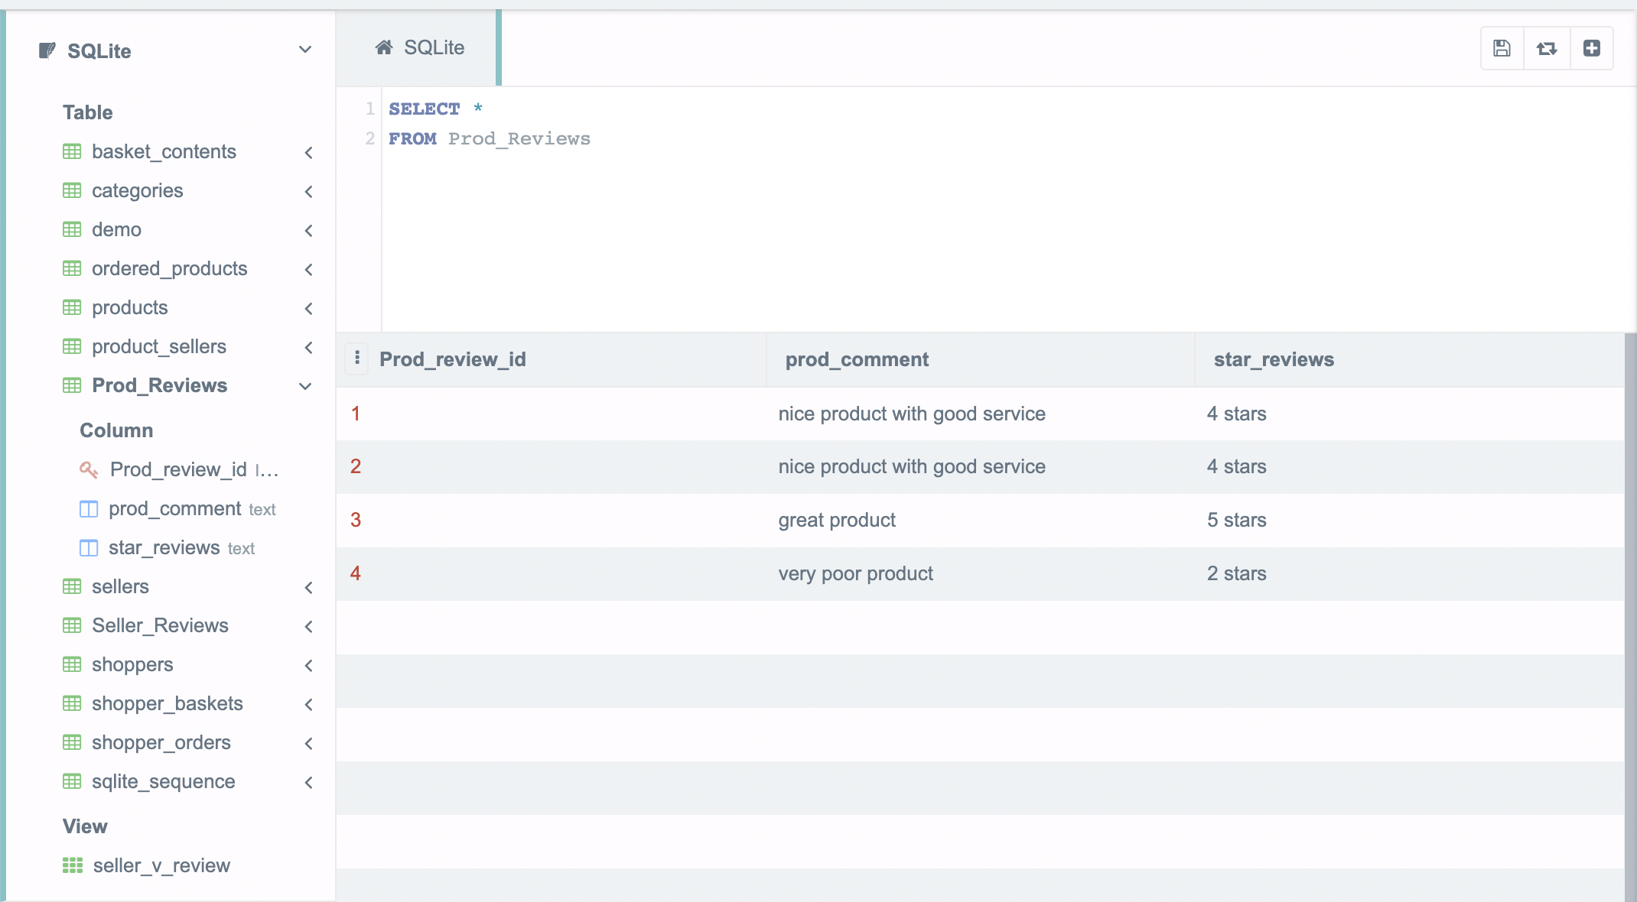

## **QUESTION D:**



CREATE VIEW seller_v_review

AS SELECT seller_id, seller_name, sr.seller_comment

FROM sellers s, seller_reviews sr

GROUP BY seller_id;

